(Approx. 2247 words)

What’s New? – CES 2016
By George Harding, Treasurer, Tucson Computer Society, AZ
www.aztcs.org
georgehardingsbd (at) earthlink.net

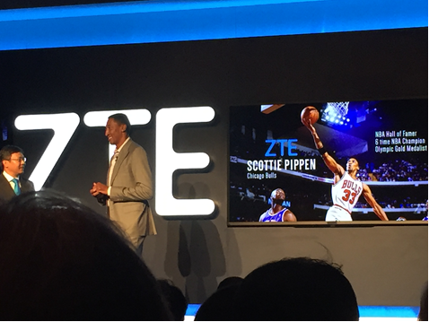
http://www.cesweb.org
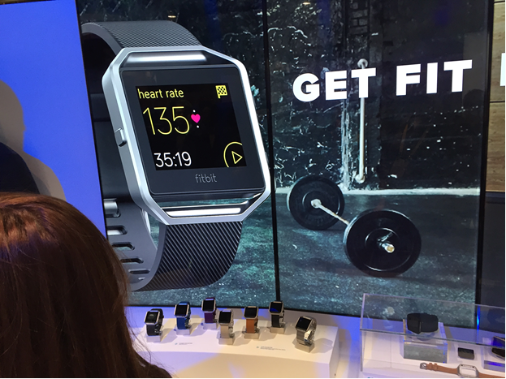
The Consumer Electronics Show is bigger and better this year. Bigger because it has expanded into three venues this year and better because there is more stuff categorized by type.

The attendees numbered some 170,000 and exhibitors were about 3,800 and they were spread over 2.4 million square feet of space. Imagine going down a line of booths 3,800 tables long and talking with half of them! It’s a time-consuming process.

As a press person, one has to make a good attempt to stop by the more significant vendors, so as to write about the significant new products and services now available. As an old person, that process gets harder each year. But your intrepid reporter made yet another valiant attempt at thorough coverage!

One thing that was noticeable was the size of the exhibit space for the larger companies, like Sony, LG, Intel, Panasonic and Samsung. The Central Hall in the Las Vegas Convention Center hosts these companies (as well as many, many smaller companies). The space for each is so large because each has so many current products. Each has TVs, external speakers, washing machines, refrigerators, Iot devices (Iot is shorthand for Internet of things, whereby you can control household and other items wherever you are), and more.

Gone are the days when a company had one principal product with a few variations. Now, each company that can produces one or more of each type of popular product. That transition is one of the reasons that exhibit space has expanded so much. The other is that every company needs to attract customers by setting up eye-catching displays, so the exhibit space is very colorful with a lot of moving objects.

The most popular product categories this year were:

- HDR 4K TVs
- Watches
- Tablets
- Health monitors
- Car automation
- Kitchen equipment
- 3-D printers
- Home automation
- Security systems
- Virtual Reality
- Drones
- Smart phones and accessories

Of course, some companies specialize in one or more of these lines and the exhibit space this year was segregated into broad product categories. This made it easier to survey 3-D printers among the various company products.

While the big companies congregate in the Central hall, there is also the North hall, two South halls, the Sands hall, the Venetian and the Aria. You can imagine the problem of contacting many of these exhibits to see what they have to offer.

I suppose next year will be even bigger and better!

Cheero …

With so many electronic devices we have today, an external charge is a necessity. This product is one of the best of the type, with its massive storage capacity and dual charging options.

The unit is fairly small, being only 3 ¼ by 3 ¾. It’s a bit heavy, but not unduly so. All the controls are on one end.

First, there’s a power button. It’s used to start a device charging and also to show the state of the internal battery’s charge. The degree of charge is shown by four LED lights.
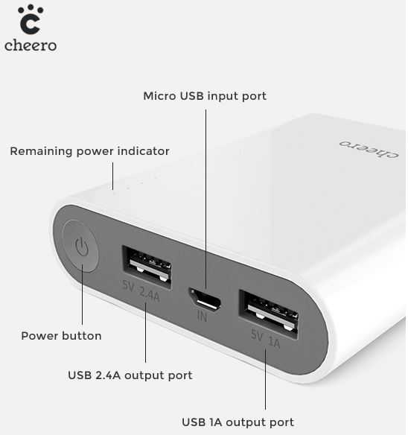
There are two USB ports. One is used for faster charging and for those devices that need the higher 2.4a capacity for charging. The other port offers 1a capacity.

The only other port is for a micro SD port, used for charging the internal battery.

It comes with two cables, one with a Lightning connector, the other with a microSD connector. Both have a standard USB plug at the other end.

I tried out a fully charged Cheero on my iPhone 6. Interestingly, when my phone was fully charged, the Cheero still showed 4 lights of charge capacity. Pretty impressive!

The internal battery is rated at 13400 mAh and is powered by a Panasonic lithium-ion product. The case for the Cheero is fire-proof plastic. A nice feature of this product is the automatic shutdown to avoid overcharge.

Cheero has a six month warranty for product defect.

Cheero external battery
http://www.cheero.net/usa/
Price $40 (currently $28.50 at Amazon.com)

Wocket Wallet …

If you’re like me, you have several credit and debit cards in your wallet or purse. Not only do all the cards make the wallet bulky, but there’s a substantial risk when you travel that losing your wallet will produce disastrous results.

Wocket provides an elegant solution! You can store all your credit and debit cards in this device in a more secure fashion than the cards themselves provide. It’s a bit larger than a credit card and about ¼” thick, so it’s more convenient that than the stuffed wallet.

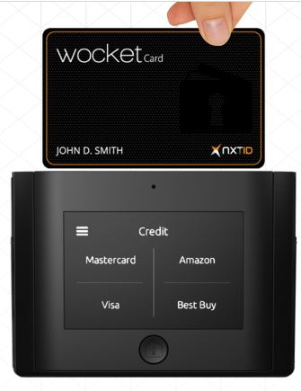
About the only thing you can’t store the information from is your driver’s license, but the Wocket case has a slot for your license, too!

The case contains the Wocket itself and a card that looks like a credit card, but isn’t. It is programmed with the data for the credit or debit card you want to use and is used just like that card – you slide it through the reader’s slot as usual. What’s dramatically different is that the data cannot be read by anyone else and is unusable after use. It will be programmed for the next use when needed.

The process of loading your cards is pretty simple. You first set up a password. I had a bit of trouble with this because I tried pressing on the screen, harder and harder when my press wasn’t recognized. I found that instead of a press, what’s required is simply a touch. The password is four characters, any combination of letters and numbers.

Next you see a screen that shows four panels, each of which can contain a card’s info. You select one of them, attach the card reader into the Wocket and slide your card through the reader. The info is transferred to the Wocket. You only have to add the CSV code printed on the back of the card, and save the result. You can name the card so it appears in the panel.

The Wocket has to be charged, but the company says a full charge should last for months. The charging cable and the card reader both use the 3.5mm socket. It’s like that used for earbuds.

Barcodes and text, such as voter's registration, loyalty and/or membership cards, can all be entered manually into Wocket as well.

I stored three credit cards in the Wocket I received for evaluation. I had difficulty modifying the description on the panel for each card, so I had to remember that Visa2 is my Fry’s card and Visa3 is my company credit card, but that wasn’t difficult.

To use your Wocket card, you first select which card you want to use from the panel, enter the password and then see the message that your Wocket card has been programmed. The screen on the Wocket shows an image of the card with your name, the last four digits of the card’s number and the CSR code. You remove the Wocket card from the case and use it like any other card.

The back of the card has a band where the magnetic stripe normally is, an area for you to sign and four electronic contacts that connect to the Wocket for programming. But you use the Wocket card the same as any other by sliding it through the retailer’s reader. The device I received does not enable the chip-reader technology that is used for recently issued cards.

I had no problem at three retail stores, but at a fourth, the card was not recognized. I had to get out my actual card and slide it.

This is an interesting technology devised to solve both the crowding we experience today from having so many cards, as well as the security problems associated with magnetic striped cards.

Wocket Wallet by NXT-ID
www.wocketwallet.com
Price $179

URB-E …

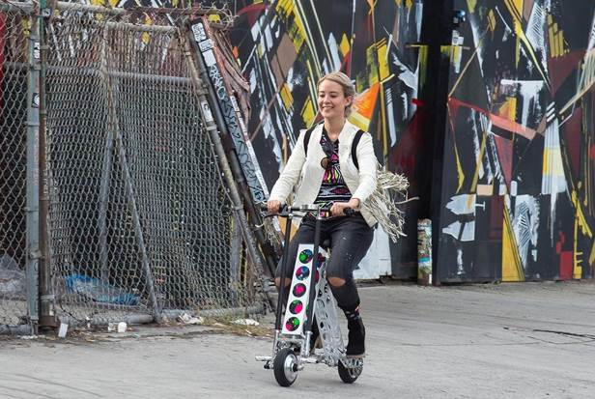
One of the very interesting products at CES was URB-E, a collapsible bicycle. As it happened, I had attended the Rose Parade in Pasadena on New Year’s day. What an event! Like many others, I had only seen it on TV. Seeing it in person is a really exciting experience.

Before the parade starts, people and vendors walk and run along Colorado Boulevard. There are those who are just getting their morning exercise, those who are checking out the crowds, those selling horns, hats, umbrellas and other stuff, those hawking food and more.

Among all this noise and confusion, there were several people, some adult, some children, riding these strange-looking bikes that appeared to be motorized in some way.

At one of the press events, I saw a couple of these bikes up close. I mentioned seeing something similar at the Rose Parade and the vendor said, “That was us!”

It is a remarkable bicycle, indeed. It is battery powered and folds up to the size of a golf bag, goes up to 15 miles an hour and weighs about 35 pounds.

It is constructed of aircraft grade aluminum and carbon fiber and is made in Pasadena. The battery is a 36v lithium ion and can carry the bike for up to 20 miles.

It has a USB port for charging phones and can be outfitted with an LED headlight, a detachable basket, a cup holder and a mount for cell phones.

This is an intriguing product unlike anything else I’ve seen. It drew quite a crowd at CES.

URB-E www.urb-e.com Price $1,500-2,200 depending on style

Virtual Reality (VR) …

One of the relatively new products to become popular is VR. When Oculus Rift announced this revolutionary product three years ago, it attracted a lot of interest. Facebook founder Mark Zukerberg thought it had so much potential that he bought the company for $2 billion! Since that time, the technology has been licensed by many companies for applications of many different sorts.

VR give you the illusion thought sight and sound that you are in a different place and are able to look around 360⁰ and in some cases move in the environment. There are several ways in which this is accomplished. Oculus and others like it provide a helmet-like viewer and headphones that are used to transport you to the other environment. Your brain is tricked into believing that you are really there because you can see all around you and even appear to move in it, as well.
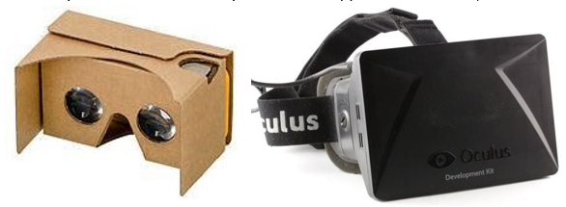
Other companies that have licensed the product use somewhat less involved methods, but which produce the same “other world” experience. One of the least expensive (free!) is Google’s Cardboard viewer. This method uses a cardboard frame in which one inserts a smartphone and runs one of the many applications geared to viewing in this device. Sound is provided by the smartphone.

Almost every day some new application for one or more of the viewer devices is announced or reported on. USA Today has a reporter assigned to bring us up to date on these new uses. Here are extracts from some of the reports:

- January 26 from the Sundance Film Festival’s New Frontier VR lounge.
- The reporter was allowed to hang out with the Star Wars droids. o The reporter wore the goggles used to enter an environment which mimics Serbia’’s war-torn lands. She entered a basement shelter and heard the sirens and felt the bomb blasts.
- The reporter entered a VR experience that explores the internal essence of blindness.
- The reporter experienced what women experience when they try to enter Planned Parenthood, crossing picket lines and hearing verbal abuse.

- January 27 from Penrose Studios in San Francisco.
- The reporter is chased by a T-Rex.
- The reporter climbs the Khumbu ice fall on Mount Everest.
- The reported experiences The Rose and I, a story of a small child whose world consists of cloud-based cities and gondola-shaped floating ships.

- February 3
- At the UCLA Center for Neurophysics, tests on rats indicate that the brain reacts differently to VR than to real world stimuli.
- At the University of Houston, experiments take patients into a realistic heroin gallery and gradually coach the patient to resist the usual physical response.
- At the University of Southern Cal, VR software has been developed virtual Afghanistan and Iraq software to help veterans plagued by PTSD.

Time will produce more interesting and innovative used for this new technology. There was a VR section at CES this January, displaying the various devices and scenarios that had been created.

For more information see en.wikipedia.org/wiki/Virtual_reality,
www.usatoday.com/story/tech/news/2016/02/04/super-bowl-fans-get-hit-virtual-realityfuture/79737124/ and www.oculus.com/en-us/

Qkey …

Here’s a solution to the problem of security breaches during online purchases. Qkey stores your card info and substitutes for entering your card info on a web site.

You use a secure web site to enter all your card info, which is then transferred to the key. The key plugs into a USB port and the info is transferred to the key.
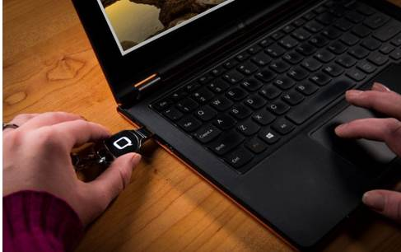

When you want to make an online purchase, you plug in the Qkey and use it to provide the credit card info to complete the purchase. No chance for a hacker to steal your keystrokes or the store’s data.

The Qkey uses the same “chip and pin” methodology that is embedded in today’s credit cards, and offers the same degree of security.

This product gives you the ease of purchasing online with maximum security. No passwords to remember, no bank information divulged and no forms to fill out.

Qkey by uQontrol qkey.com Price $99 currently for pre-orders

